Đề thi tiếng Anh học kì 2 lớp 4 năm 2021 - Đề số 1
Question 1: Chọn từ khác loại
1. A. about B. where C. how D. who
2. A. collect B. read C. do D. like
3. A. Art B. Music C. subject D. History
4. A. blue B. puppet C. purple D. red
Question 2: Dựa vào tranh để hoàn thành các câu sau
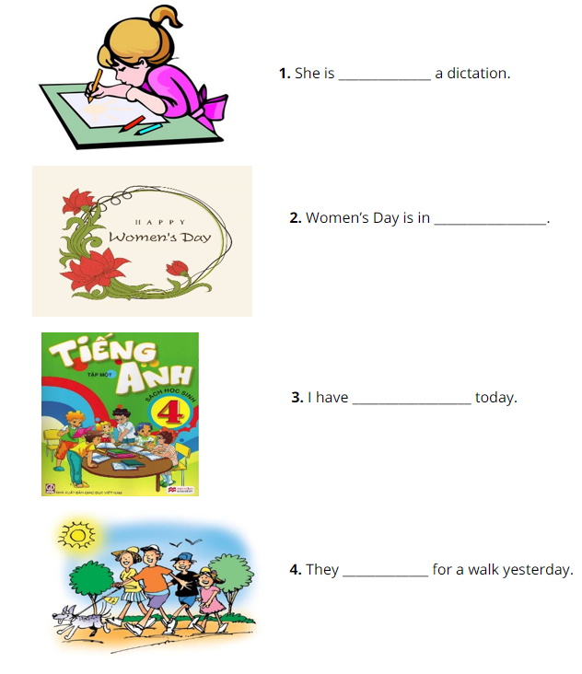
Question 3: Chọn từ thích hợp trong hộp thoại để điền vào chỗ trống
happy England friend dance club
This is my new (1) ______________. Her name is Linda. She is from (2) ______________. She can sing many Vietnamese songs. In her free time, she goes to music (3) ______________. She is (4) ______________ there.
Question 4: Tìm lỗi sai trong các câu sau và sửa lại cho đúng
1. She don’t like playing badminton. | _____________________
2. Sandy is an pupil at Hong Bang primary school. | _____________________
3. We have English in Friday. | _____________________
4. My birthday is on the twenty of December. | _____________________
Question 5: Sắp xếp các từ sau thành câu hoàn chỉnh
1. a/ fly/ want/ I/ to/ kite/.
____________________________________________________
2. They/ school/ yesterday/ went/ to.
____________________________________________________
3. When/ birthday/ your/ is/?
____________________________________________________
4. can/ cannot/ jump high/ Tom/ but/ run fast/.
____________________________________________________
5. Monday/ has/ on/ Tom/ PE/.
____________________________________________________
6. doing/ What/ they/ are/?
____________________________________________________

Đáp án đề thi học kì 2 môn tiếng Anh lớp 4 (Đề số 1)
Question 1:
1. A | 2. D | 3. C | 4. B
Question 2:
1. She is writing a dictation.
2. Women’s day is in March.
3. I have English today.
4. They went for a walk yesterday.
Question 3:
1. FRIEND | 2. ENGLAND
3. CLUB | 4. HAPPY
Question 4:
1. don’t ⇒ doesn’t
2. an ⇒ a
3. in ⇒ on
4. twenty ⇒ twentieth
Question 5:
1. I want to fly a kite.
2. They went to school yesterday.
3. When is your birthday?
4. He can jump high but cannot run fast.
5. Tom has PE on Monday.
6. What are they doing?

Đề thi học kì 2 tiếng Anh lớp 4 năm 2021 - Đề số 2
Question 1: Chọn từ khác loại
1. A. Go B. Travel C. Plane D. Build
2. A. To B. You C. With D. For
3. A. Monkey B. Lion C. Tiger D. Zoo
4. A. Holiday B. Summer C. Winter D. Fall
Question 2: Đọc và tick vào tranh thích hợp
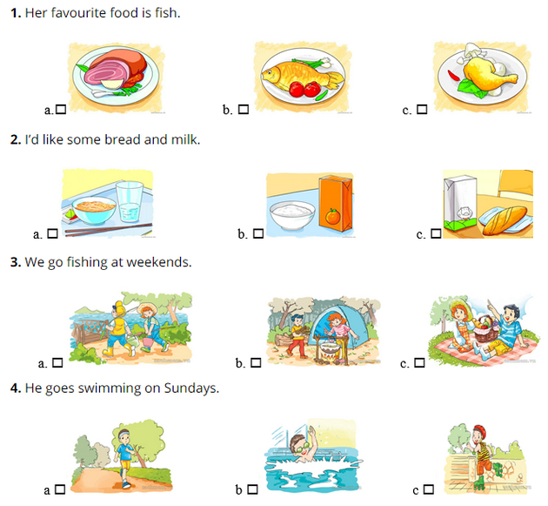
Question 3: Đọc đoạn văn và trả lời câu hỏi
It is Sunday today. Phong and Mai go to four places. First, they go to the bookshop because Mai wants to buy some books and pens. Then they go to the pharmacy because Phong wants to buy some medicine. After that, they go to the zoo because they want to see the animals. Finally, they go to the bakery. They want to buy something to eat because they are hungry.
1. How many places do Phong and Mai go?
__________________________________________________.
2. What do they buy at the pharmacy?
__________________________________________________.
3. Do they go to the post office?
__________________________________________________.
4. Why do they go to the zoo?
__________________________________________________.
Question 4: Sắp xếp các từ sau thành câu hoàn chỉnh
1. a/ time/ It’s/ great.
________________________________________________________.
2. Where/ this/ you/ summer/ going/ are?
________________________________________________________?
3. homework/ stay/ because/ I/ home/ have to/ at/ do/ I.
________________________________________________________.
4. is/ Ho Chi Minh/ He/ to/ going/ city.
________________________________________________________.

Đáp án đề thi tiếng Anh lớp 4 học kì 2 (Đề số 2)
Question 1: Chọn từ khác loại
1. C | 2. B | 3. D | 4. A
Question 2: Đọc và tick vào tranh thích hợp
1. B | 2. C | 3. A | 4. B
Question 3: Đọc đoạn văn và trả lời câu hỏi
1. They go to four places.
2. They buy some medicine.
3. No, they don’t.
4. They go to the zoo because they want to see the animals.
Question 4: Sắp xếp các từ sau thành câu hoàn chỉnh
1. It’s a great time.
2. Where are you going this summer?
3. I stay at home because I have to do homework.
4. He is going to Ho Chi Minh city.

