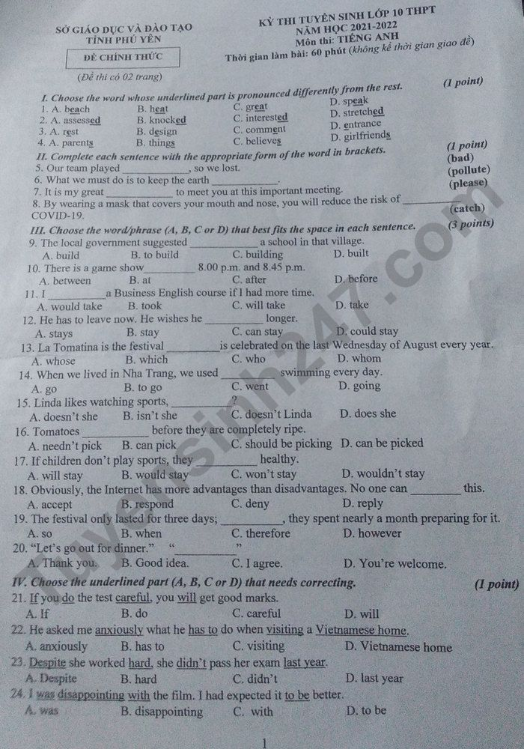
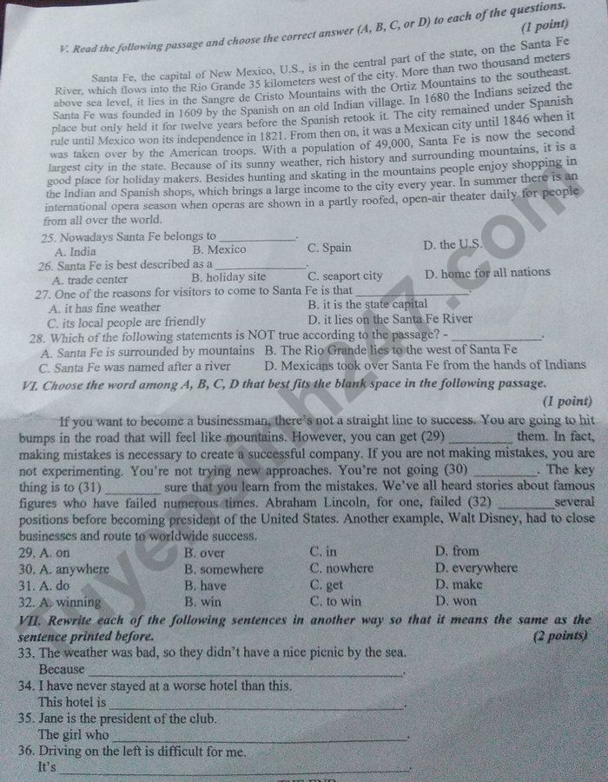
Đáp án đề thi tiếng Anh vào 10 năm 2021 tỉnh Phú Yên
1. C | 2. C | 3. B | 4. A | 5. badly | 6. | 7. pleasure | 8. catching
 |  |  |  |  | unpolluted
9. C | 10. A | 11. A | 12. D | 13. B | 14. B | 15. A | 16. D
17. C | 18. C | 19. D | 20. B | 21. C | 22. B | 23. A | 24. B
25. D | 26. B | 27. A | 28. D | 29. B | 30. A | 31. D | 32. C
33. the weather was bad, they didn’t have a nice picnic by the sea
34. the worst one (that) I have ever stayed
35. is the president of the club is Jane
36. difficult for me to drive on the left

