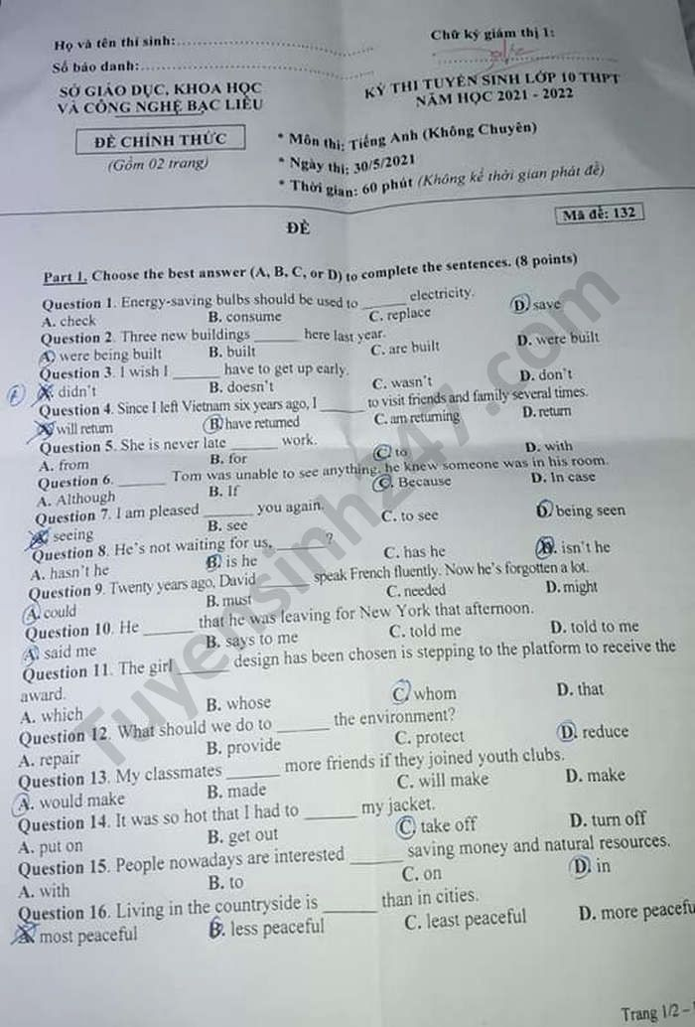
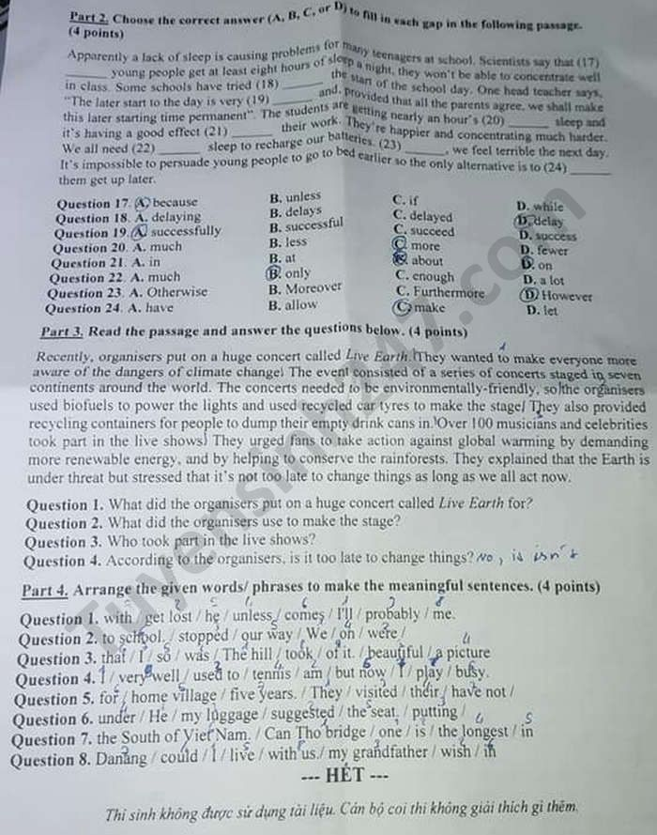

Đáp án đề thi vào 10 môn Tiếng Anh tỉnh Bạc Liêu 2021 (Mã đề 132)
Part 1 + 2:
1. D | 2. D | 3. A | 4. B | 5. B | 6. A
7. C | 8. B | 9. A | 10. C | 11. B | 12. C
13. A | 14. C | 15. D | 16. D | 17. B | 18. A
19. B | 20. C | 21. D | 22. C | 23. A | 24. C
Part 3:
1. They wanted to make everyone more aware of the dangers of climate change.
2. They used recycled car tyres to make the stage.
3. Over 100 musicians and celebrities took part in the live shows.
4. No, it isn’t.
Part 4:
1. I’ll probably get lost unless he comes with me.
2. We were stopped on our way to school.
3. The hill was so beautiful so that I took a picture of it.
4. I used to play tennis very well but I am busy now.
5. They have not visited their home village for five years.
6. He suggested putting my luggage under the seat.
7. Can Tho bridge is one the longest one in the South of Viet Nam.
8. I wish my grandfather could live with us in Danang.

