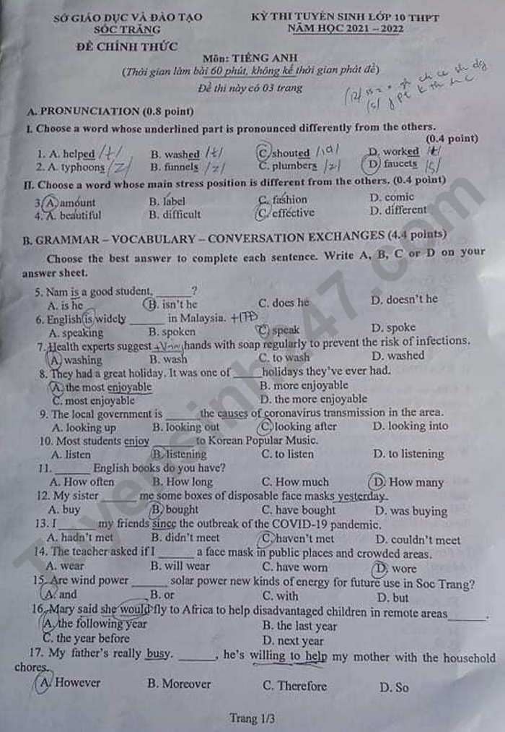
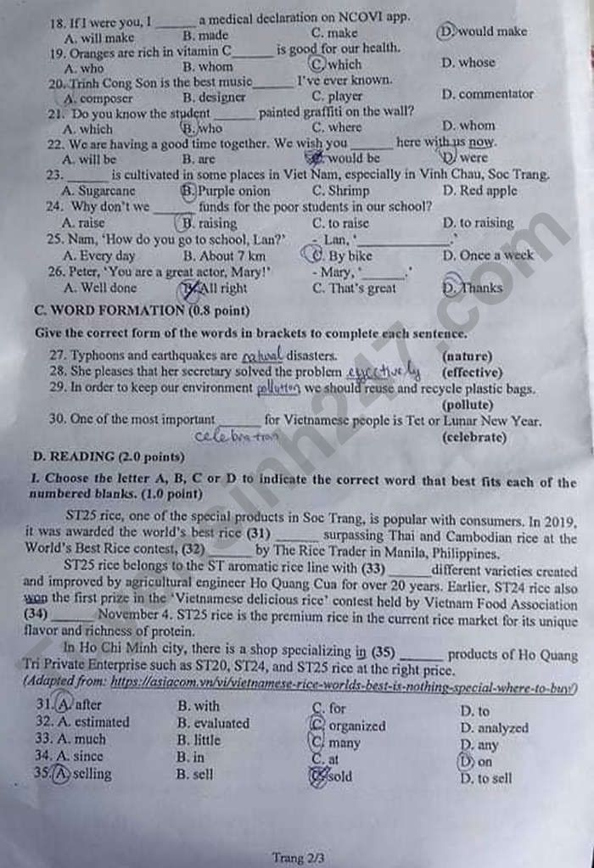
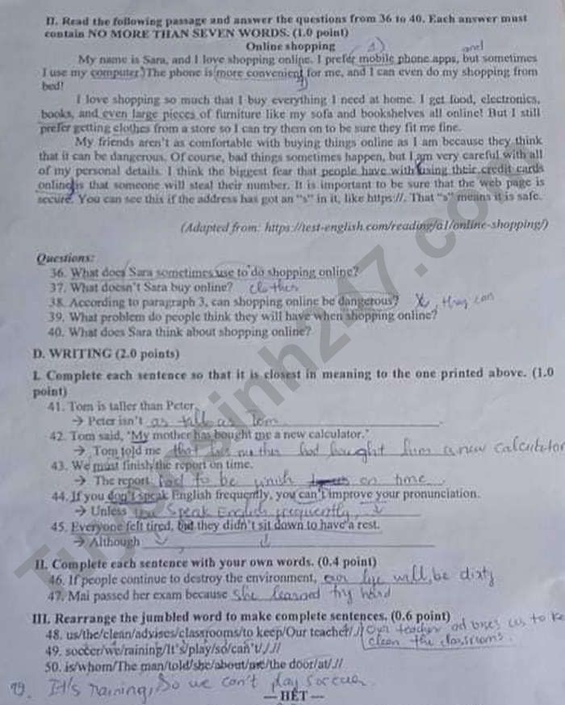
Đáp án đề thi vào 10 môn Anh tỉnh Sóc Trăng 2021
1. C | 2. D | 3. A | 4. C | 5. B | 6. B | 7. A
8. A | 9. D | 10. B | 11. D | 12. B | 13. C | 14. D
15. A | 16. A | 17. A | 18. D | 19. C | 20. A | 21. B
22. D | 23. B | 24. A | 25. C | 26. D
27. natural
28. effectively
29. pollution
30. celebration
31. A | 32. C | 33. C | 34. D | 35. A
36. her computer
37. clothes
38. Yes, it can./ Yes
39. using their credit cards online so that someone will steal their number
40. She loves shopping online.
41. as tall as Peter.
42. (that) his mother had bought him a new calculator.
43. must be finished on time.
44. you speak English fluently, you can’t improve your pronunciation.
45. everyone felt tired, they didn’t sit down to have a rest.
46. Gợi ý: Sử dụng cấu trúc: S + will/ won’t + V_nguyên thể
47. Gợi ý: Sử dụng thì quá khứ đơn: S + Ved/ bqt + O.
48. Our teacher advises us to keep the classrooms clean.
49. It’s raining, so we can’t play soccer.
50. The man whom she told me about is at the door.

