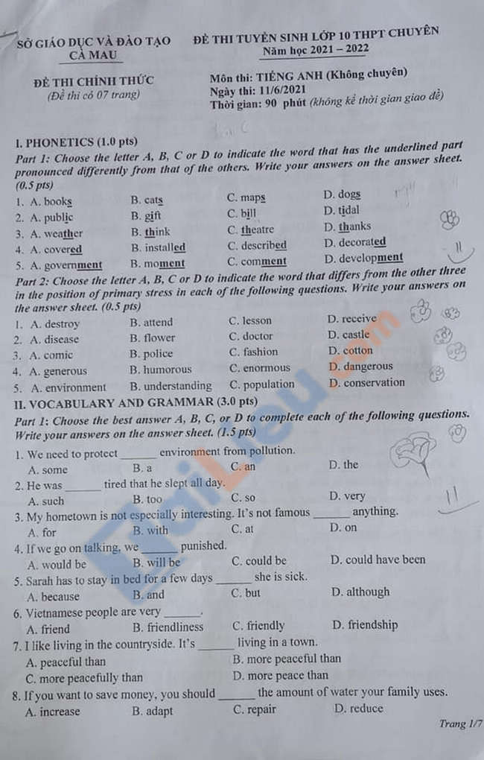
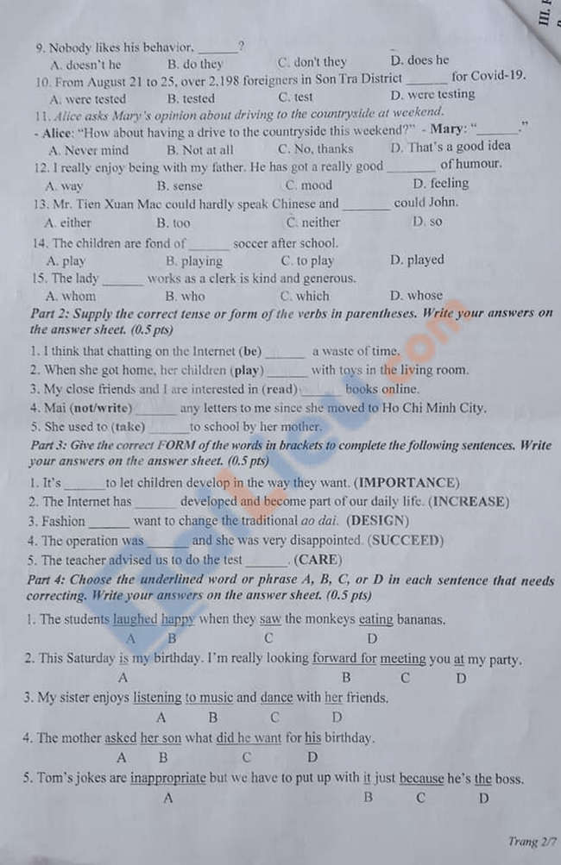
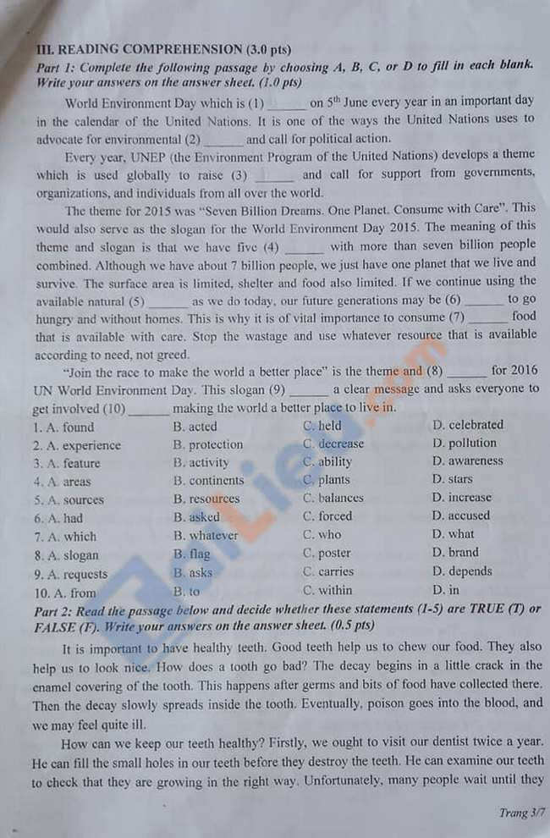
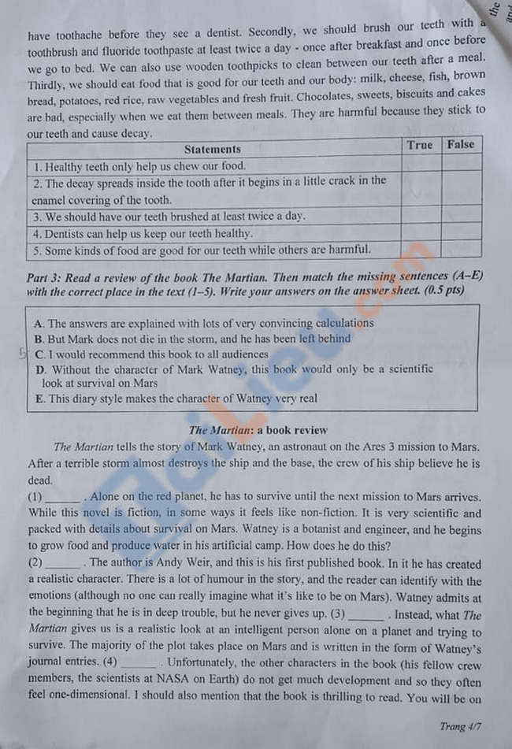
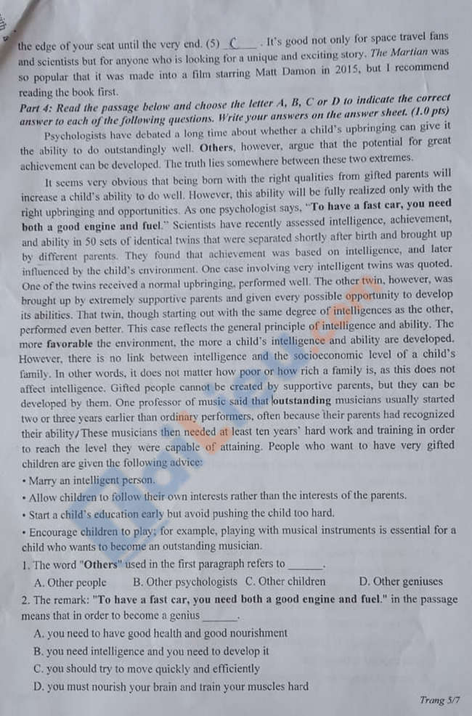
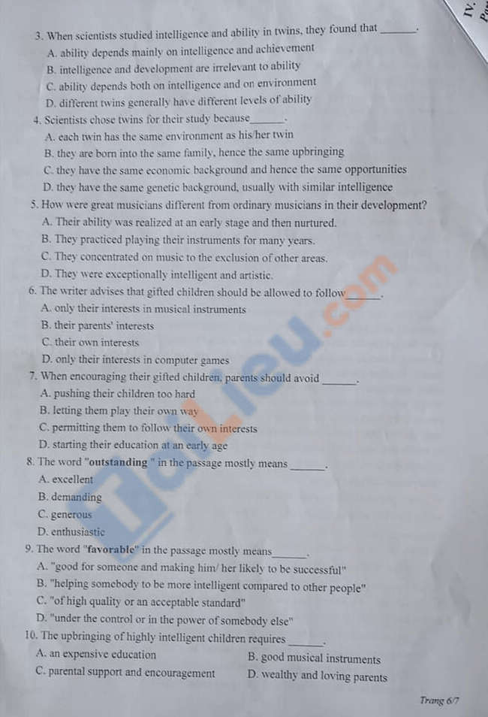
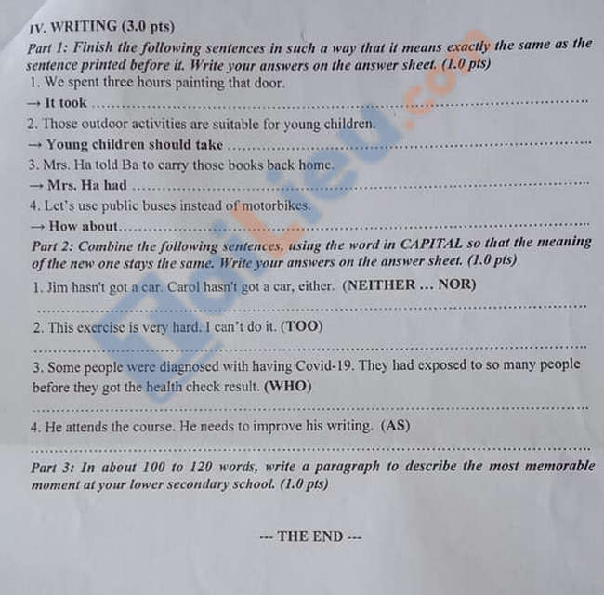

Đáp án đề thi tiếng Anh vào 10 năm 2021 tỉnh Cà Mau
I. PHONETICS
Part 1:
1. D 2. D 3. A 4. D 5. C
Part 2:
1. C 2. A 3. B 4. C 5. A
II. VOCABULARY AND GRAMMAR
Part 1:
1. D 2. C 3. A 4. B 5. A 6. C 7. B 8. D
9. B 10. A 11. D 12. B 13. C 14. B 15. B
Part 2:
1. is
2. were playing
3. reading
4. hasn’t written
5. be taken
Part 3:
1. important
2. increasingly
3. designers
4. unsuccessful
5. carefully
Part 4:
1. B 2. B 3. C 4. C 5. B
III. READING
Part 1:
1. C 2. D 3. D 4. B 5. B
6. C 7. A 8. A 9. C 10. D
Part 2:
1. False 2. False 3. True 4. False 5. True
Part 3:
1. B 2. A 3. D 4. E 5. C
Part 4:
1. B 2. B 3. C 4. D 5. A
6. C 7. A 8. A 9. A 10. C
IV. Writing
Part 1:
1. us three hours to paint that door.
2. part in those outdoor activities.
3. Ba carry those books back home.
4. using public buses instead of motorbikes?
Part 2:
1. Neither Jim nor Carol has got a car.
2. This exercise is too hard for me to do.
3. Some people who had exposed to so many people before they got health check result were diagnosed with having Covid-19.
4. He attends the course as he needs to improve his writing.

