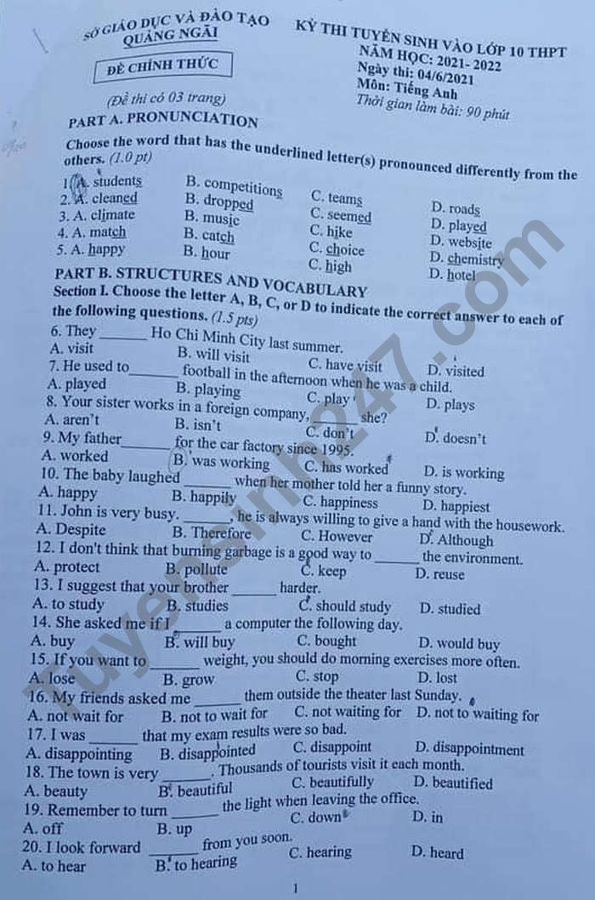
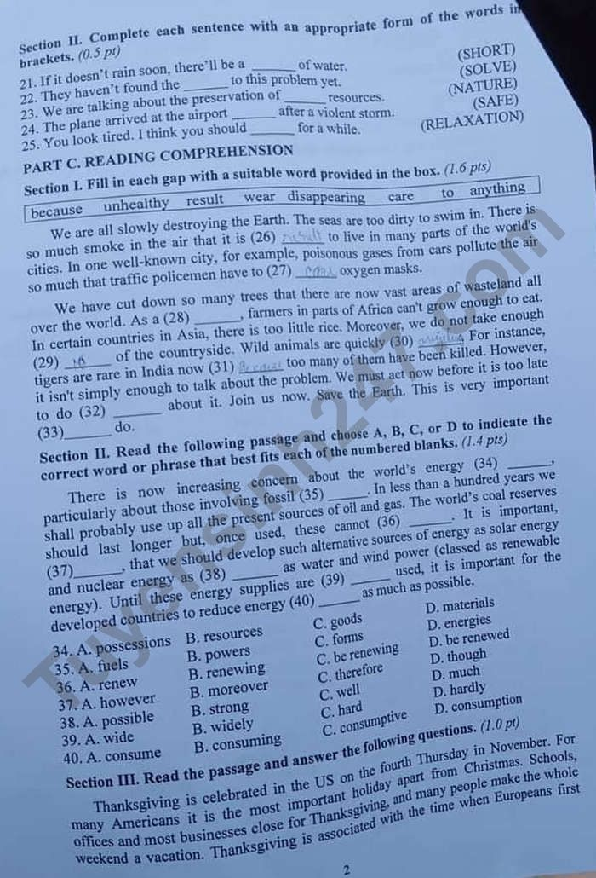
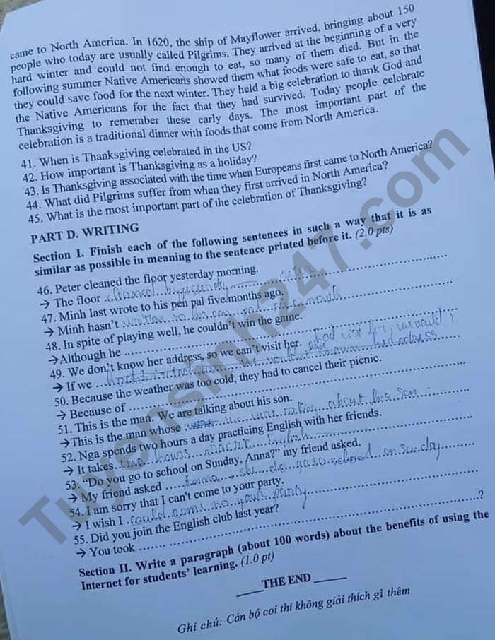

Đáp án đề thi tiếng Anh vào 10 năm 2021 tỉnh Quảng Ngãi
PART A.
1. A 2. B 3. B 4. D 5. B
PART B.
Section I.
6. D 7.C 8. D 9.C 10. B 11. C 12. A 13. C
14.D 15. A 16. B 17.B 18.B 19. A 20.B
Section II.
21. shortage 22. solution 23. natural 24. safely 25. relax
PART C.
Section I.
26. unhealthy 27. wear 28. result 29. care
30. disappearing 31. because 32. anything 33. to
Section II.
34. B 35. A 36. D 37. C 38. C 39. B 40. D
Section III.
41. It is celebrated on the fourth Thursday in November.
42. It is the most important holiday apart from Christmas.
Or: For many Americans, it is the most important holiday apart from Christmas.
43. Yes, it is. / Yes.
44. They could not find enough to eat.
45. It is a traditional dinner with foods that come from North America.
Or: The most important part of the celebration is a traditional dinner with foods that come from North America.
PART D.
46. was cleaned by Peter yesterday morning2
47. written to his pen pal for five months
48. played well, he couldn’t win the game
49. knew her address, we could visit her
50. the cold weather, they had to cancel their picnic
51. son we are talking about
52. Nga two hours a day to practice English with her friends
53. Anna if/whether she went to school on Sunday
54. could come to your party
55. part in the English club last year didn’t you

