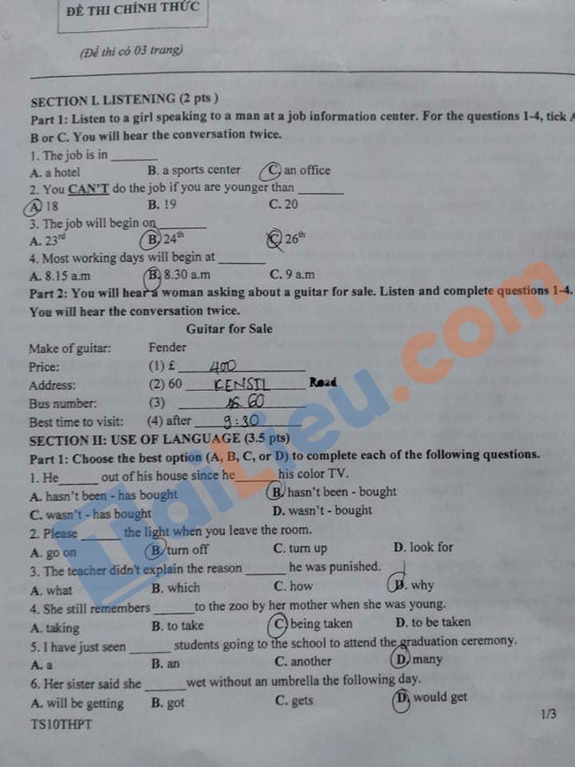

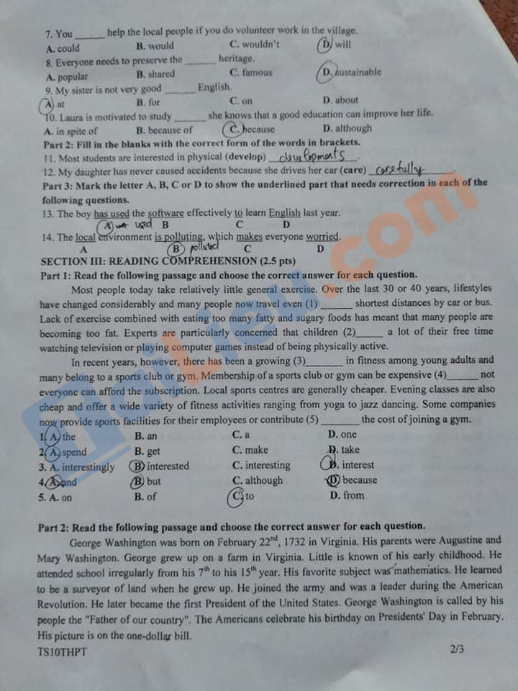

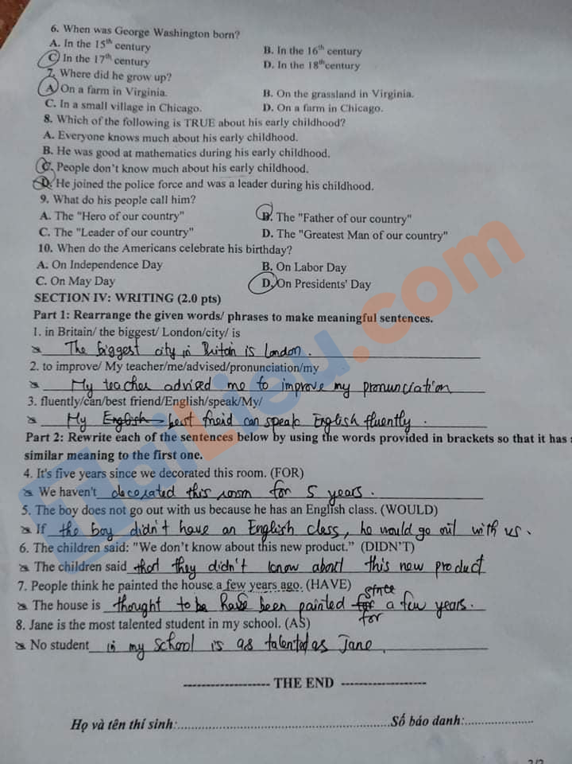

Đáp án đề thi tiếng Anh vào 10 năm 2021 tỉnh Quảng Trị
Section II
Part 1
1. B 2. B 3 – D 4 – C 5 - D
6 – D 7 – A 8 – D 9 – A 10 - C
Part 2
11 – development 12 - carefully
Part 3.
13 – A 14 - B
Section III. Reading
Part 1.
1. A 2. A 3. D 4. A 5. C
Part 2
6. C 7. A 8. C 9. B 10. D
Section IV
1. London is the biggest city in Britain
2. My teacher advised me to improve my pronunciation.
3. My best friend can speak English fluently.
4. We haven't decorated this room for 5 years.
5. If the boy didn't have an English class, he would go out with us.
6. The children said that they didn't know about this new product.
7. The house is thought to has been have been painted for a few years.
8. No student in my school is as talented as Jane

