ĐỀ THI TUYỂN SINH VÀO LỚP 10 MÔN ANH SỞ GD&ĐT TỈNH AN GIANG 2021 – ĐỀ CHÍNH THỨC (CÓ ĐÁP ÁN)
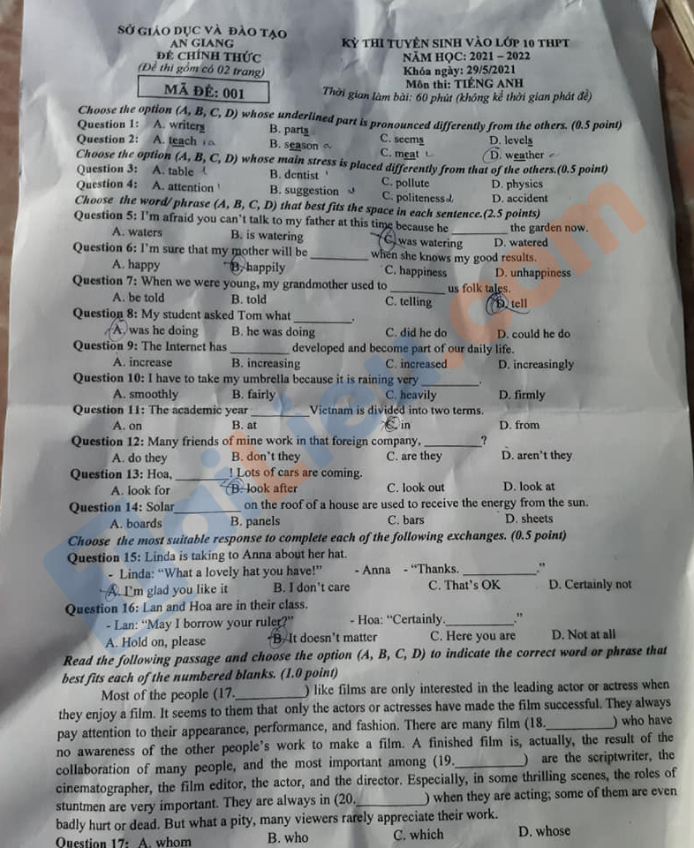
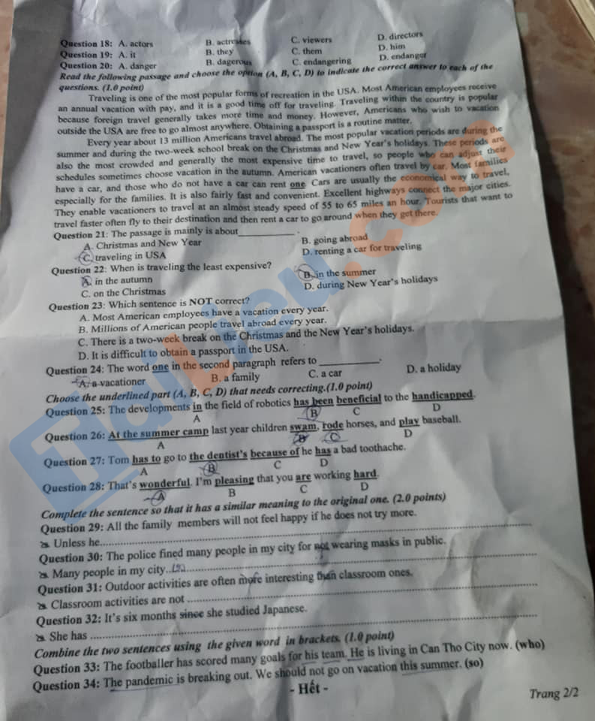

HƯỚNG DẪN GIẢI CHI TIẾT ĐỀ THI VÀO 10 MÔN ANH – AN GIANG
I. TRẮC NGHIỆM:
1. B | 2. D | 3. C | 4. D | 5. B | 6. A | 7. D | 8. B | 9. D | 10. C
11. C | 12. B | 13. C | 14. B | 15. A | 16. C | 17. B | 18. C | 19. C | 20. A
21. C | 22. B | 23. D | 24. C | 25. B | 26. D | 27. C | 28. B

II. TỰ LUẬN
29. try more, all the family members will not feel happy.
30. were fined for not wearing masks in public.
31. as interesting as outdoor activities.
32. studied Janpanese for six months.
33. The footballer who is living in Can Tho City now has scored many goals for his team.
34. The pandemic is breaking out, so we should not go on vacation this summer.

